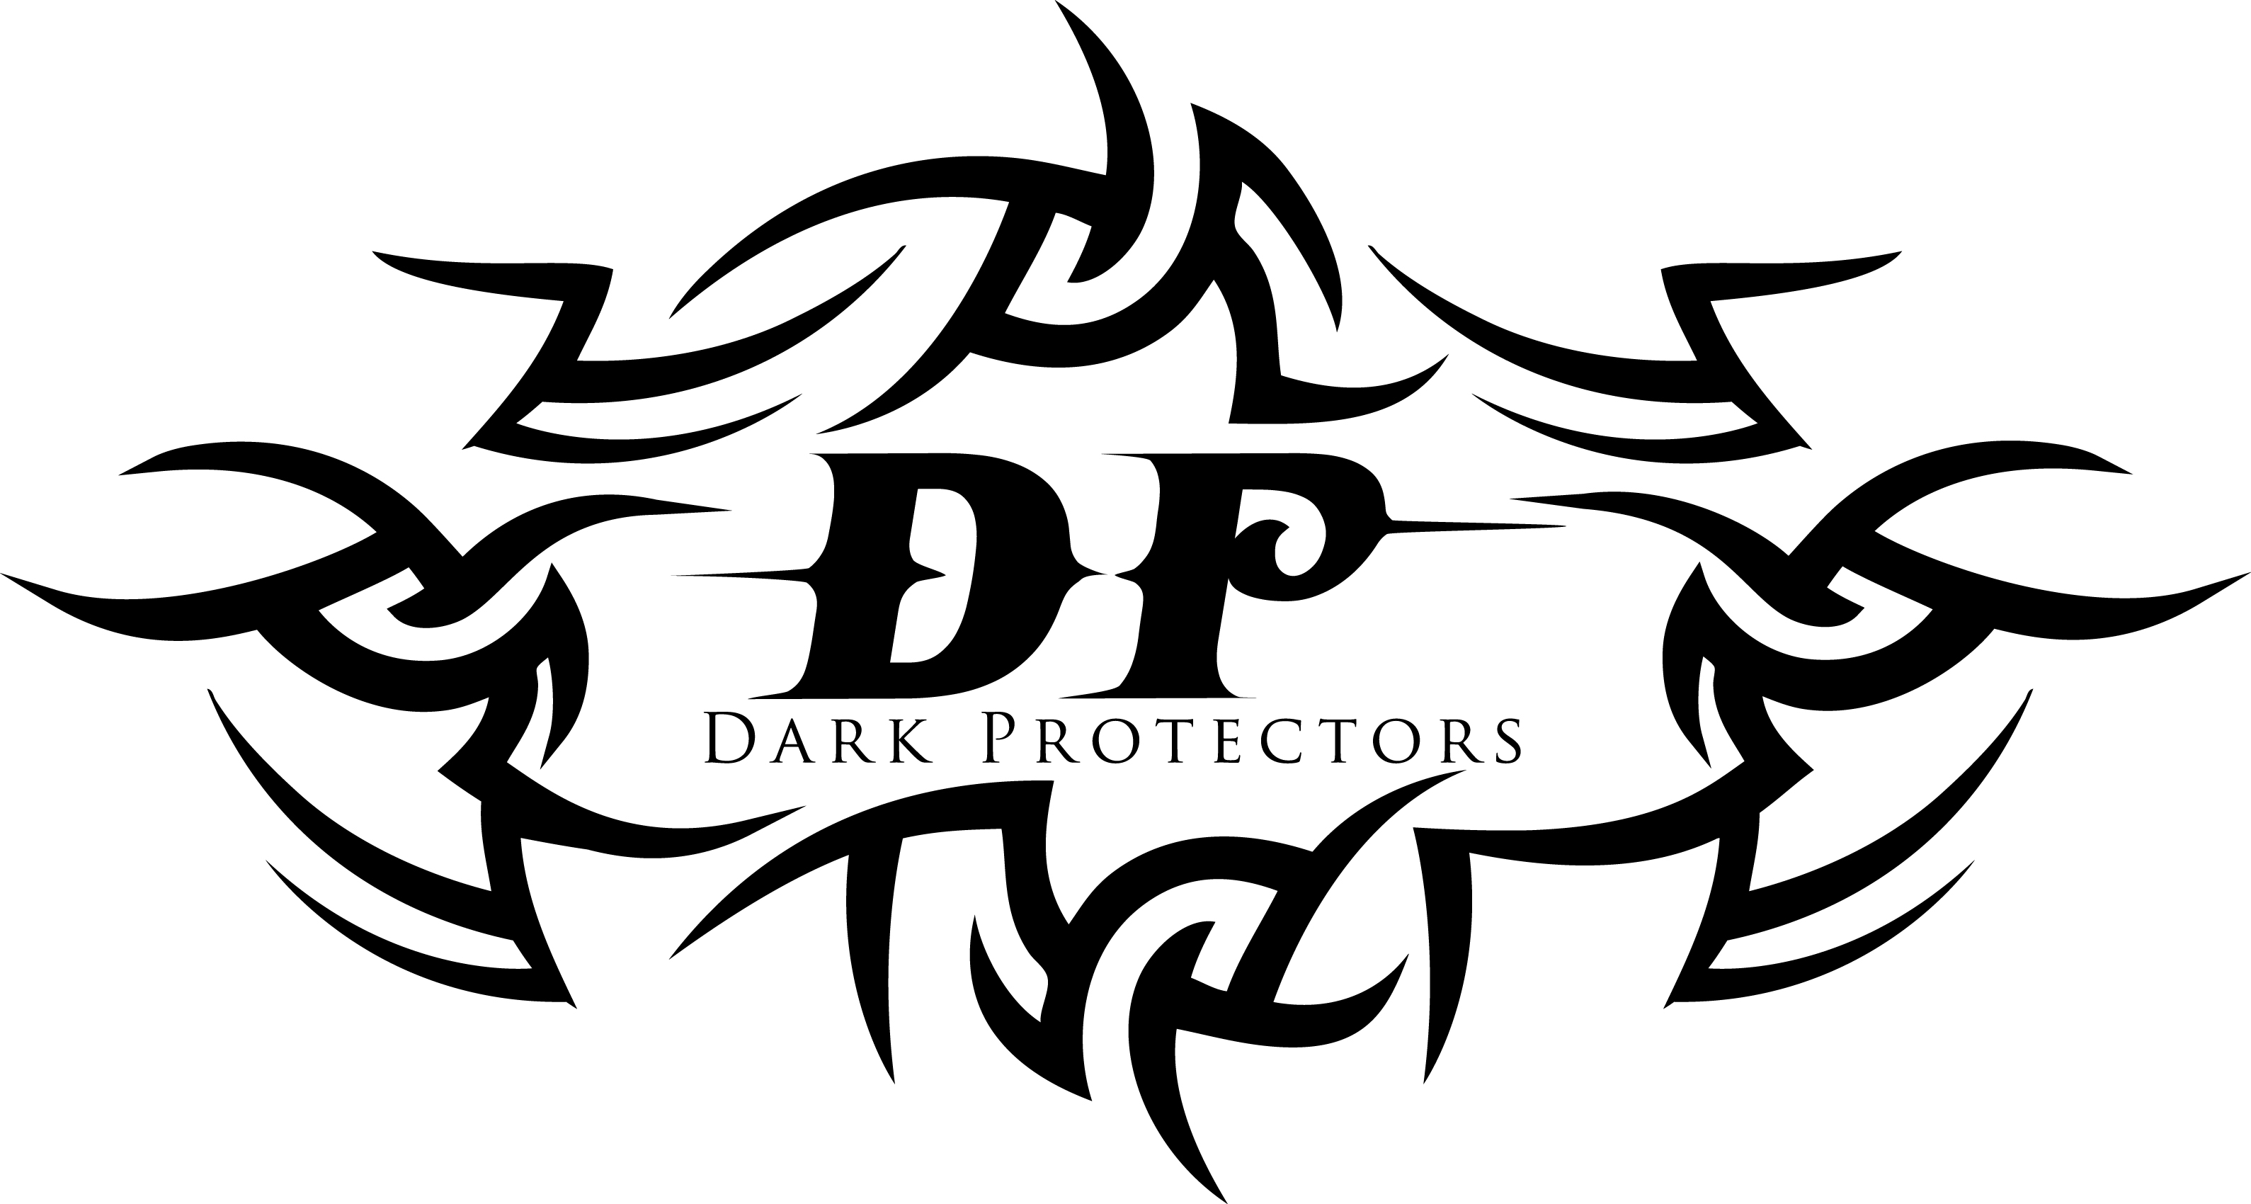

**SERIES LIST IN ORDER:**

1. **FATED:** Talen and Cara’s book – available in Print and E-Book
2. **CLAIMED:** Dage and Emma’s book – available in Print and E-Book
   1. **TEMPTED:** Max and Sarah’s novella – available in E-Book now, Print format early 2014
3. **HUNTED:** Conn and Moira’s book – available in Print and E-Book
4. **CONSUMED:** Jordan and Katie’s book – available in Print and E-Book
5. **PROVOKED:** Kane and Amber’s book – available in Print and E-Book
   1. **TWISTED:** Terrent and Maggie’s novella –E-Book now, Print format late 2014
6. **SHADOWED:** Jase and Brenna’s book – available in Print and E-Book
   1. **TAMED**: Caleb and Lily’s novella – available in E-Book May, Print format late 2014
7. **MARKED:** Janie’s book - Available in print and ebook December 2014

